Eman Ragab Mohamed

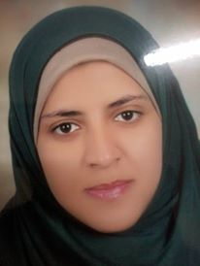

Tel: 01064006642

e-mail: mervatragab82@yahoo.com
PERSONAL INFORMATION:
Date of Birth: 13-2-1989
Gender: (Female)
Marital Status: (.married)
Nationality: Egyptian

EDUCATION:
Assiut University , Assiut,Egypt ( B.Sc. of Medicine and Surgery 2012)
Demonstrator of medical Biochemistry 2013
TRAINING:
Training on EndNote : MRCE at faculty of science, Assiut | December 2014…

